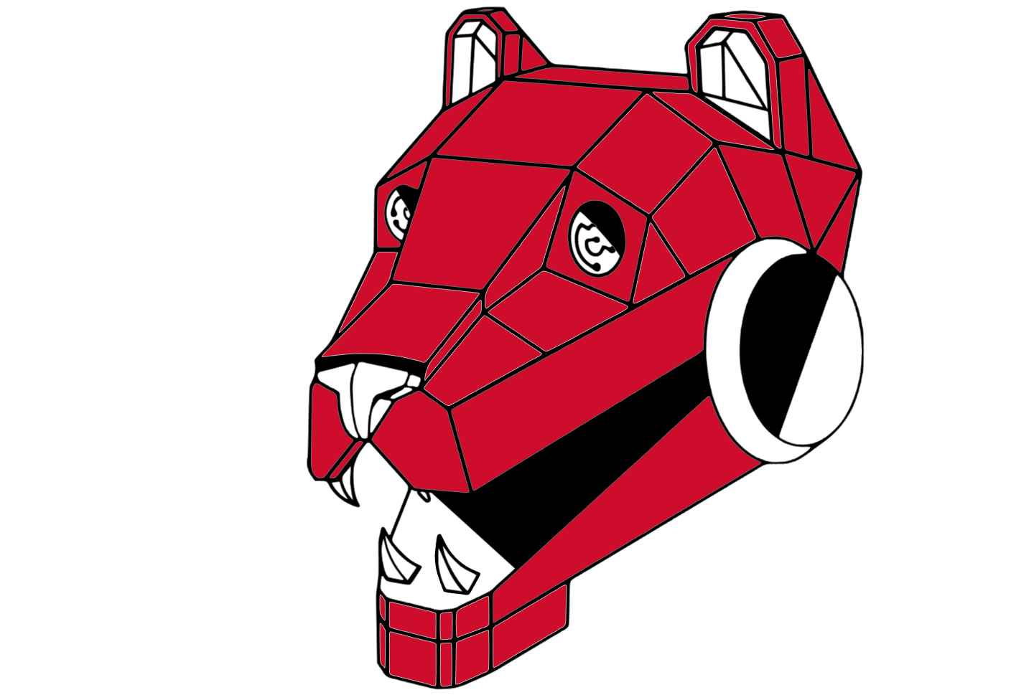

Panthinators Robotics
Welcome Packet

Please read completely
Sign and return the required forms within 1 week

Welcome Panthinators
Welcome to the Spring Lake Park Panthinator Robotics FIRST Robotics Competition (FRC) team 8234. This handbook is intended to contain the information needed for all 8234 team members to understand the administrative and logistical procedures for FRC Team 8234 Panthinator Robotics. It is updated yearly by Core Leadership to accurately represent current standards.
Our Mission
Our mission is to open students up to the possibilities of STEM through FIRST Robotics. We promote an inclusive, team environment where students can safely explore new skills and confidently develop into innovative thinkers and compassionate leaders.
About FIRST
FIRST, For Inspiration and Recognition of Science and Technology, is a non-profit organization dedicated to inspiring young people to be leaders and innovators in science and technology. Through programs such as FIRST Robotics Competition and FIRST Lego League, students are encouraged to excel in the areas of science, technology, engineering, and mathematics. FIRST was founded in 1989 by Dean Kamen (inventor of the Segway and the insulin pump) and has since become an international organization that has reached hundreds of thousands of students from elementary school through high school. For more information, visit https://www.firstinspires.org/.
About FRC
FIRST Robotics Competition (FRC) is FIRST's oldest robotics program. It is designed to provide a rigorous engineering challenge to high school students as well as teach leadership, collaboration, and project management. Over three thousand teams have anywhere from fewer than ten to over one hundred students with guidance and support from adult coaches. Each year, every FRC team builds a robot to compete in a game released in early January.
Gracious Professionalism
As part of its mission to encourage student leadership and collaboration, FIRST promotes Gracious Professionalism as one of its core values in all levels of competition. Their website describes this ideal as follows: “With Gracious Professionalism, fierce competition and mutual gain are not separate notions. Gracious professionals learn and compete like crazy, but treat one another with respect and kindness in the process. They avoid treating anyone like losers. No chest thumping tough talk, but no sticky-sweet platitudes either. Knowledge, competition, and empathy are comfortably blended.”
Coopertition®
FIRST also promotes the philosophy of Coopertition®, which is described as “displaying unqualified kindness and respect in the face of fierce competition. Coopertition is founded on the concept and a philosophy that teams can and should help and cooperate with each other even as they compete. Coopertition involves learning from teammates. It is teaching teammates. It is learning from Mentors. And it is managing and being managed. Coopertition means competing always, but assisting and enabling others when you can.
Our Teams:
Business and Marketing team-
The business team is arguably one of the most important teams. Without the business team organizing the fundraising and writing the grants, we wouldn’t have the funds needed to keep the team running. If you are interested in accounting, business, social media, graphic design, or photography this team is perfect for you. There are several jobs that business team members are tasked with, often split up into 2 groups, but coming together to help fill any gaps that are needed throughout the year.
Business members are the ones who are tasked with managing the team's budget and financial goals. Securing funding is crucial to help us cover the team expenses, from parts for the robot to competition fees, allowing the team to continue to function and compete. This is done in a few ways:
- Fundraisers- You will work to find and organize fundraisers. Once a fundraiser is decided, you will design the flyers to advertise it, keep track of sales, and help organize and distribute any products after sales.
- Grants- Search to find grants we qualify for and apply for them. Once applied for, tracking the grants that have been applied for and whether we have been approved.
- Sponsorships- Identifying and approaching potential sponsors, developing sponsorship proposals and keeping track of the sponsors and money received.
The Marketing Team are the ones who are tasked with promoting our team. This is done through creating promotional materials, running our social media accounts, creating content for our website, photographing the team during meetings and events, writing and sending newsletters.
There are also other very important roles that the Business and marketing team as a whole take on. Such as designing the yearly shirts, creating button designs, graphics for the websites and flyers. And most importantly outreach to the community through planning and organizing community service events, managing outreach activities, finding and setting up events such as parades and vendor events.
Build Team-
The build team is in charge of creating the final physical product. This is done by using applied mechanical engineering and using electronics and wiring so it can run code. If your interest includes power tools, wiring electrical, and real life applications of engineering then you should consider the build team. There are a lot of things that always need to get done, we are very hands on, and if you don’t know anything we’ll teach you!
- Mechanical engineering is applied when building the various projects we build throughout the year and that is especially important when prototyping as we need to see how the theoretical design will function in real life with friction and gravity.
- Wiring is very important as the robots would not function without it. We wire both power and communication throughout the robot, having to trim and add connectors to wires, run them in an understandable way while taking into account how the robot would move, and control them by setting them in a fixed place.
- Organizing is so crucial for speedy assemblies and when not properly taken care of our closet becomes a mess. We are also usually in charge of the cleanliness and organization of the closet because if we don’t know what’s happening in there we won't get anything done
- Tool use will be properly trained on every power tool and woodshop tool we have. Common tools include drills, table saw, bandsaw, dremel, and basic tools like wrenches and screw drivers.
Code Team-
The code team is in charge of creating, uploading, and testing the code/software needed for the robot to function. This includes setting up the programs needed to use the robot (including uploading our code onto the robot and other hardware checks), writing the various commands & subsystems needed to tell each hardware component what to do, and creating tele-op (human-controlled) actions which happen after some human input (and more!). We also plan to create autos (automatic driving of the robot in the first 15s of the game) and use vision (cameras on the robot which can track tags on the field) to further our abilities on the field this year.
In order to work on some of these really cool things, you will need to learn Java, the programming language we use. However, we will help you learn Java to the extent that you need to code the bot, and lots can still be learned without any Java experience! If you do have coding experience already, fantastic; for those that don't, you will be taught everything you need to know.
CAD Team-
Computer Aided Design (CAD), we do strategic analysis to find the best robot archetype. Then we plan out a design for the robot. After that we make a high detail CAD model of the robot that includes everything from the boxtube to the individual rivets.
Pre Season
CAD and design training!!!!
- Required before we can do anything else
Projects
- Demo robot
- Robot upgrades
- Individual Subsystems
Build Season
- Week 1
  - Block CAD only (ideal finish is early to mid week 2)
- Week 2-3 (Week 2-3 is when you will put the most hours in)
  - 95-99% of functional CAD is done
- Week 4-comp
  - Subsystem redesign
What is expected of you:
- Complete all offseason training
- Work on robot CAD at home
  - Around 4-6 hours during the beginning of the season
- To learn about designing for manufacturing and coding(We will have training for this)
Drive Team-
The Drive Team is primarily about driving the robot at competition, but it also has aspects of helping in both the design and build process in order to make sure the driver is understanding how to use the bot, and if the bot will work for the driver's skill. The drive team also coordinates scouting to ensure important information is collected from other teams, as well as strategy for what we will do in matches.
The Drive Team has lots of training with driving the robot when in and off season, along with having to learn the rules of the game and strategize with your fellow team members and other drive teams when competition rolls around.
Not every member of the drive team needs to do driving, there are also roles in other areas.
- The coach is the person who is scanning the field for game pieces or opposing robots, telling the primary and secondary driver about what they see.
- The primary driver is the one actually controlling the robot, the one that makes the robot move around the field, making sure to pay attention to both the field itself and what the coach is saying(This role has a try-out process for the competition driver).
- The secondary driver is the one that more often than not will control the moving elements of the robot itself, things that allow the bot to actually participate in the game itself.
- The human player is a person who will be standing near the field doing random tasks that correlate to the game, usually involving a game piece or a way to interact with the field in some way.
The drive team as a whole cannot operate without every member of the team doing their part, if even one of the members is uncoordinated or unwilling to do the job, then the drive team won’t be at its best during the match.
Inventory and Asset Management Team-
The Inventory and Asset Management team is responsible for maintaining a comprehensive and organized catalog of all team resources, including parts, raw materials, tools, and electronics. Our mission is to support the technical and build teams by ensuring they have the right supplies at the right time, minimizing waste, and preventing delays caused by missing components. We utilize efficient tracking systems to manage stock and provide transparency to the entire team.
Inventory tracking: Utilize a digital and/or physical system (e.g., spreadsheet, database, kanban board) to track all parts and materials. This includes recording items purchased from suppliers like AndyMark and REV Robotics, as well as components from the Kit of Parts.
Parts management:
- Organize and label all parts in the workshop and pit, ensuring that components are easy to find and access.
- Replenish frequently used items, such as nuts, bolts, washers, and electrical connectors, to prevent shortages during the critical build season.
Tool organization:
- Maintain a clean and orderly tool area in the shop and at competition, with clear labeling and a "check-in/check-out" system for specialized equipment.
- Perform regular checks to ensure all tools are present and in working order.
Supply chain and purchasing:
- Work with sub-team leads to forecast material needs and place timely orders to avoid delays.
- Track purchases and manage the inventory budget in collaboration with the Business sub-team.
Competition support:
- Create a well-organized and clearly labeled system for packing the robot cart and pit materials for competition.
- Manage spare parts and tools during events to ensure the drive team and mechanical members can quickly perform repairs and maintenance.
Skills developed:
Members of the inventory team gain valuable skills in:
- Project management and organization
- Attention to detail
- Database and spreadsheet management
- Process and workflow optimization
- Communication and collaboration with other sub-teams
Safety Team-
Mission statement: To foster a culture of safety for all team members and mentors in the workshop, at events, and in their daily lives, while following and promoting the principles of Gracious Professionalism®.
Philosophy: Safety is a priority over speed. All members are responsible for creating a safe environment and looking out for one another.
Safety Team Leadership
- Leads the team's safety initiatives, including managing the safety manual and binder.
- Conducts and/or coordinates regular safety meetings and training sessions.
- Serves as the main point of contact for safety advisors at competitions.
- Oversees the "pit crew" to ensure the workspace and tools are maintained and organized at all times.
- Maintains and stocks the team's first-aid kit and personal protective equipment (PPE).
Safety Mentors:
- Sets a positive example for all students and practices safe behavior consistently.
- Provides guidance and encouragement to the safety team and the entire team.
- Helps oversee safety during robot fabrication, especially when students operate hazardous machinery.
Responsibilities-
- Comply with all safety procedures established by the team and the official FIRST guidelines.
- Immediately report any unsafe practices or hazardous conditions to a Safety Captain or mentor.
- Ensure they and others wear appropriate PPE, including safety glasses and closed-toed shoes, in designated areas.
- Demonstrate safe behavior and maintain an orderly workspace, especially in the pit.
- Must complete a required safety training course before operating any tools or machinery.
- Must be supervised by an experienced team member or mentor until they demonstrate proficiency and safe practices.

